Name: ___________________________________________ Date: ________________ Period: ___
The “How-To” Project
Purpose:
This project is designed to target both language arts skills (punctuation, grammar, spelling, capitalization, etc.) as well as develop communicative abilities, such as giving directions.
The Project: You are to create a How To Make a Whirligig manual. How you choose to design your manual will be up to you. Some options include a pamphlet, a book, a poster, a powerpoint/prezi, or a video. You will need to choose a program that you already know well; in other words, do not choose to create a video if you have never used video editing software and are not willing to dedicate the extra time to learning it.
Graded on:
- The completion of a Whirligig (assembled and painted)
- The how-to manual with correct spelling, capitalization, punctuation, and grammar
- Responsible and productive use of class time
- Must use 6 of 8 vocabulary words in your pamphlet

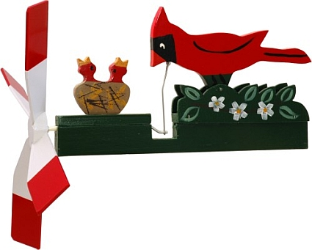
Planning Pages – Your Manual Must Include This Information!
- What is a whirligig? Where would a person find one? __________________________________________________________________________________________________________________________________________________________________________________________________________________________________________
- Write a sales pitch for your whirligig. Promote it. Use figurative language!
__________________________________________________________________________________________________________________________________________________________________________________________________________________________________________
- What materials will you need?
  - Wood
  - Paint & Brush
  - Tube
  - Wire
  - Handsaw
  - Clamps & Vice
  - Whirligig pattern
  - _________________
  - _________________
  - _________________
- List the steps for making a whirligig. Pretend you are telling someone who has never worked with wood before.
  - _____________________________________________________________________
  - _____________________________________________________________________
  - _____________________________________________________________________
  - _____________________________________________________________________
  - _____________________________________________________________________
  - _____________________________________________________________________
  - _____________________________________________________________________
  - _____________________________________________________________________
  - _____________________________________________________________________
  - _____________________________________________________________________

- What tips or tricks would you suggest? ______________________________________________________________________________________________________________________________________________________________________________________________________________________________________________________________________________________________________________________________________________________________________________________________________

